|  |
| --- |
| Centrilla corporation |
| Technical Proposal |
| IT SYSTEM FOR BOOKING ROOMS AND FACILITIESSPECIFICATION |
|  |
|  |
|  |

|  |
| --- |
| This is a proposal created for VinIT Solutions for one of its clients. The document is intended to deliver a technical overview and screens for a system to reserve rooms and other facilities. |

Contents

Overview 3

The high level architecture diagram of the proposed system. 5

Booking Management 6

Add/Update a booking 6

Search booking 7

Dashboard (Calendar) 7

Customer Management 8

Add/Update Customer 8

Search customer 9

User Management 10

Add/Update a user 10

Search/Delete user 10

Roles/Rights Management 11

Add/Update custom role 11

Search /Delete roles 11

Settings 12

Add/Update institution 12

Add/Update/Delete Councils 13

Add/Update/Delete Rooms per school 13

Add/Update/Delete bed types 13

Add/Update/Delete rate plan 13

Add/Update/Delete room rate plan 14

Add/Update/Delete credit card types 14

Add/Update/Delete sources 14

Add/Update/Delete resource per school, per hour 14

Reports 15

# Overview

* This system cannot be extended from the Hotel Reservation system, the reason will be reasoned out at later stages in this document.

Below are the high level modules break down and their sub functionalities:

1. User Management Module
   1. Users
      1. Add Users (Internal users, External customers)
      2. Edit/Delete Users (Internal users, External customers)
      3. Search Users (Internal users, External customers)
      4. Reporting section
   2. User Roles and Rights
      1. Add Roles
      2. Edit/Delete Roles
      3. Search Roles
      4. Manage Roles and Rights in the system
2. Facility Management Module (Screen shots not included)
   1. Equipment/Other add-ons (Customer specifications)
      1. Add Equipment Items
      2. Edit/Delete equipment Items
      3. Search equipment
      4. Reporting section
   2. Facility Management (Main facilities)
      1. Add Facilities (Class rooms, swimming pools, e.t.c.)
      2. Edit/Delete equipment Items
      3. Search equipment
      4. Reporting section
   3. Facility Dashboard
3. Reservation Module
   1. Manage reservations
      1. Reserve facilities
      2. Manage customer specifications of reservations
      3. Approval process for 3rd parties
      4. Check resource availability
   2. Payments for reservations
      1. Manage payment specifications
   3. Reservation reports
4. Payment Gateway integration for payments
   1. Online payments via credit/debit cards
   2. Transaction reports
5. Communication Module
   1. Email notifications
   2. Sms notifications

* The **scrum framework** will be adopted for managing this project. Scrum framework is the most used **Agile methodology** in the industry that yield best results.
* The architecture of this project will be a **client server** hence this **system will not require individual installations** per user. Once the application is hosted and the server configured **all the users will be able to access the system via internet**.
* The system will be designed to be compatible with most popular **computer and mobile browsers**. This will enable users to connect to the system with ease from any location.
* User access restrictions can be controlled by assigning **customisable roles**.

The complete system will be designed so that we can provide access to the centralised data to **third parties** via an API, this **architecture is significantly different** from what we used to design the Hotel reservation system. This require more effort and take a longer time for development but will allow us to easily configure and give access to other parties to access our data and allow them to integrate our data with their systems. I have noticed this in the requirement document as well.

## The high level architecture diagram of the proposed system.

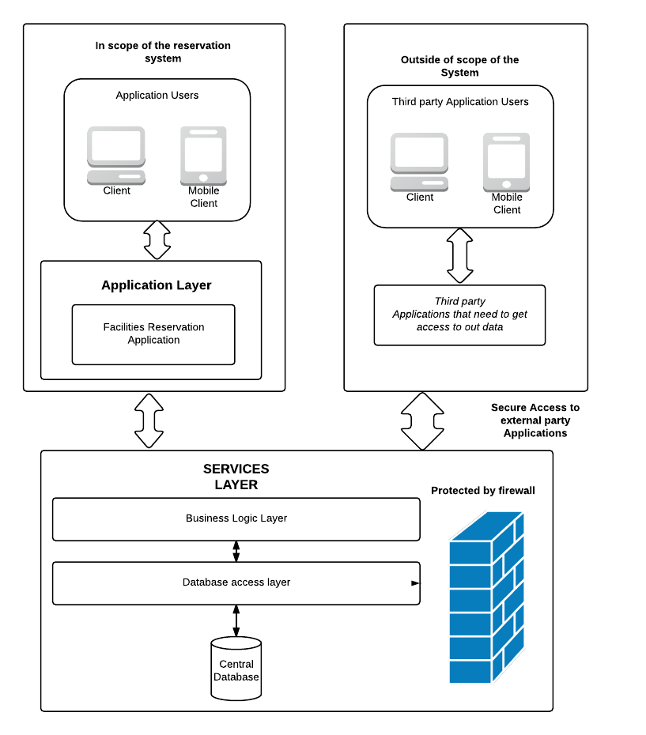

# Booking Management

|  |
| --- |
| **Controls/Components on forms can be changed on actual system. This is only a depiction.** |

Booking is available through the system for resources which are maintained by the school such as rooms, grounds, gym etc.

## Add/Update a booking

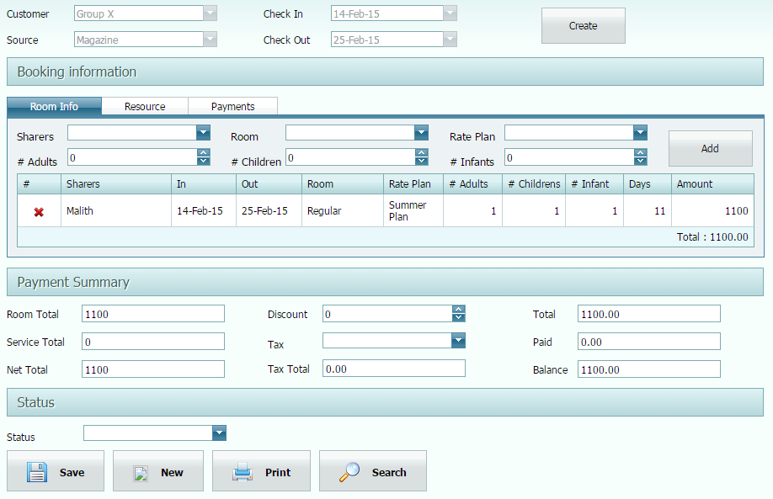

Booking can be a room or any resource which is belongs to a school. Payment can be routed through a payment gateway or offline collected.

All the booking are reflected on the Dashboard (Calendar Control)

## Search booking

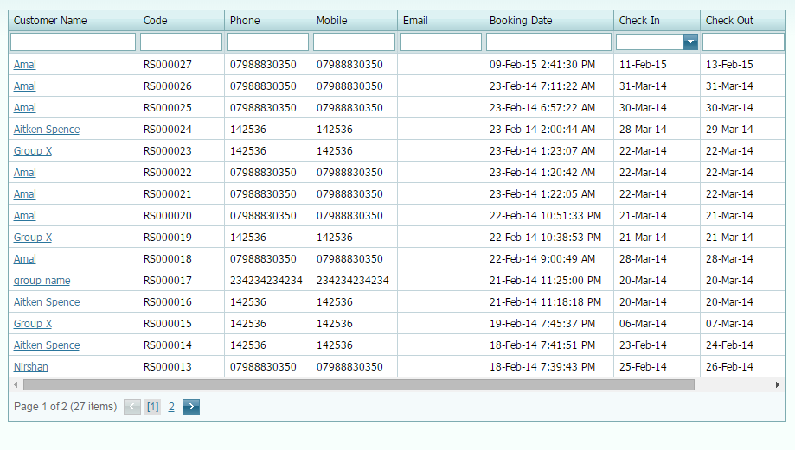

## Dashboard (Calendar)

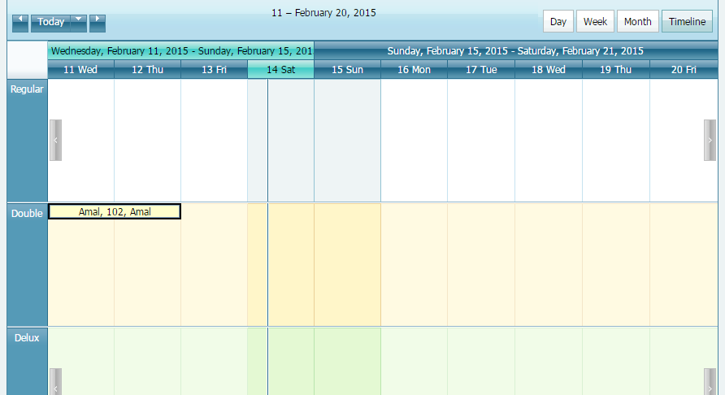

# Customer Management

|  |
| --- |
| **Controls/Components on forms can be changed on actual system. This is only a depiction.** |

## Add/Update Customer

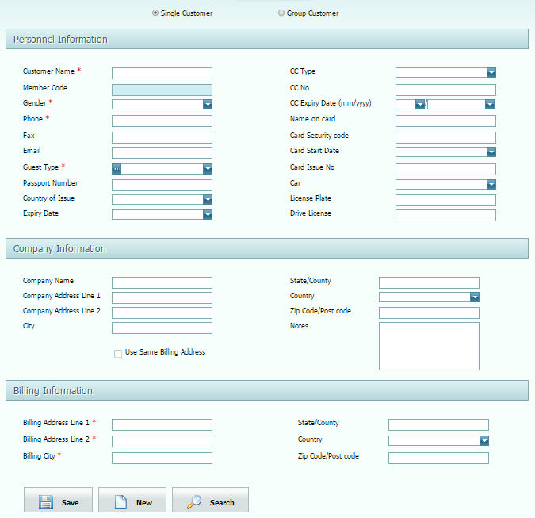

## Search customer

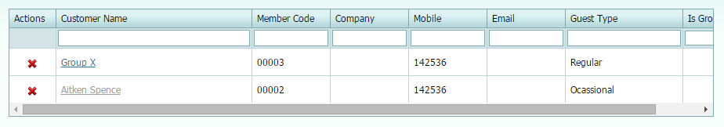

# User Management

|  |
| --- |
| **Controls/Components on forms can be changed on actual system. This is only a depiction.** |

## Add/Update a user

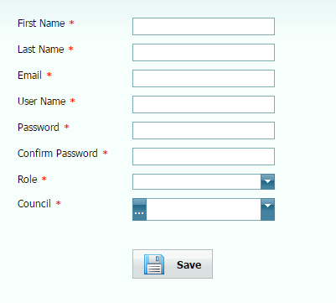

### Search/Delete user

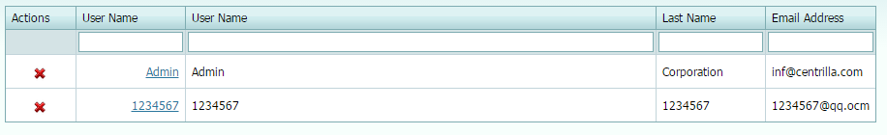

## Roles/Rights Management

### Add/Update custom role

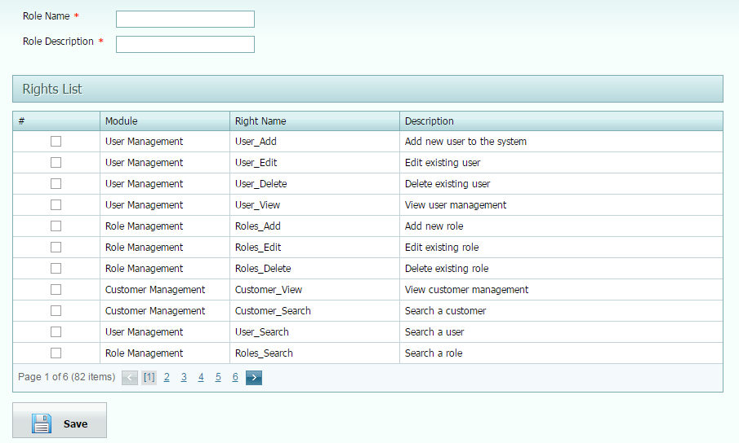

### Search /Delete roles

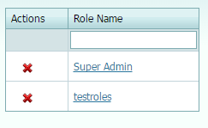

# Settings

|  |
| --- |
| **Controls/Components on forms can be changed on actual system. This is only a depiction.** |

Settings mentioned below are global variables for the intended system.

Add/Update institution*

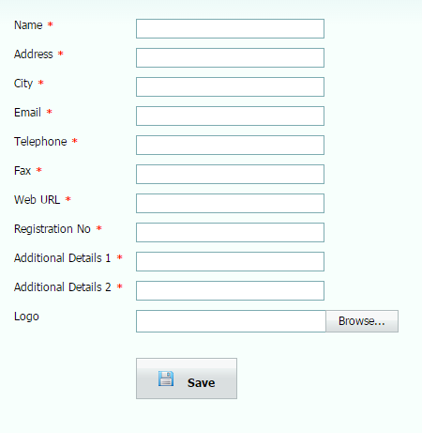

* Institution is treated as who owns the schools

## Add/Update/Delete Councils

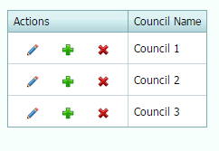

## Add/Update/Delete Rooms per school

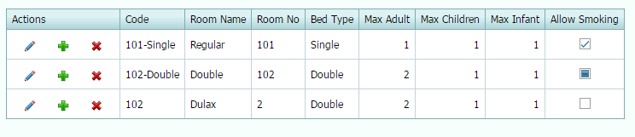

## Add/Update/Delete bed types

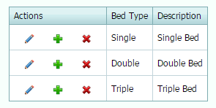

## Add/Update/Delete rate plan

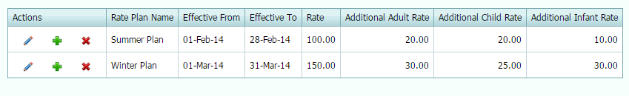

## Add/Update/Delete room rate plan

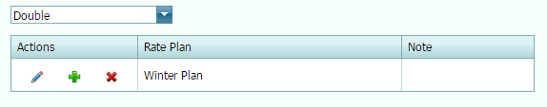

## Add/Update/Delete credit card types

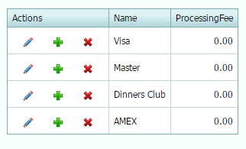

## Add/Update/Delete sources

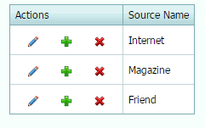

## Add/Update/Delete resource per school, per hour

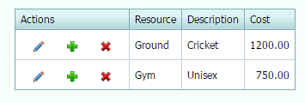

# Reports

Different kinds of reports are available through the system like Guests, Bookings, Payment, Dirty Rooms, Rooms, and Occupancy etc. On demand reports can be integrated in to the system. Report data can be filtered, sort and group also possible to export to different formats like PDF, CSV and Excel etc.

Reports can be generated as per school or as whole and any additional report can be integrated.